Money Cannot Help Her

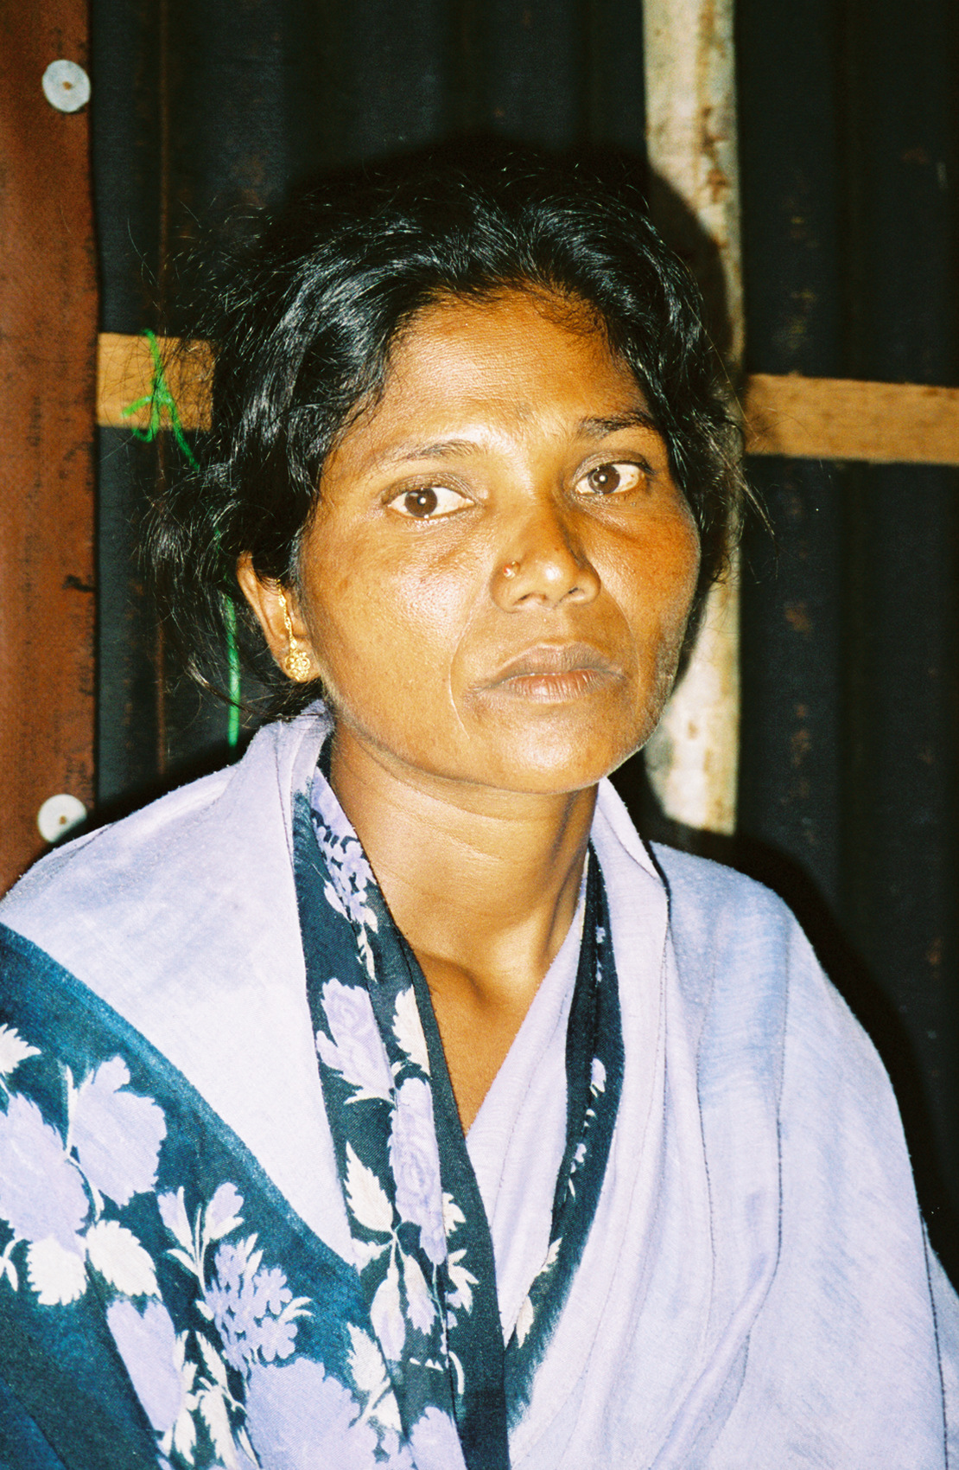
Ballayar, INDIA — In another time and place, 30-year old Manjula, wearing a violet-colored sari that complements her striking facial features and lovely skin tone, could be mistaken for a model. But her vacant, red-rimmed eyes tell a story of hardship oceans away from a world of runways or high fashion. In a single morning, the light in Manjula’s eyes went out, and darkness, despair and emptiness settled in its place.

On December 25, Manjula was a mother of three children; by the end of the following day she was no longer a mother.

It is stifling hot in the tin-roofed building where Manjula tells her story. As she begins, a neighbor of hers standing against the wall sways unsteadily and lets out a low moan. Tears are streaming down her face and her knees begin to buckle. It’s not the heat that causes her to swoon, but grief – the same grief so familiar to Manjula.

That Sunday late in December began like any other. Manjula went to the market while her husband, Vaidiyanathan, was out on his boat fishing. Their three children (two sons and one daughter) ranging in age from 3 to 7, were resting and playing in their thatched home. The water came suddenly, sweeping up Manjula and carrying her along until she managed to grab on to the top of a palm tree.

Once the first wall of water receded, Manjula bolted to her house and found nothing. No sign of a dwelling or any of her children. She feared the worst, recalling, “When I couldn’t find the children, I wanted to die. So I jumped into the water.” The violent waves ripped away her clothes. Her neighbors pulled her from the water and gave her something to wear.

Meanwhile, Vaidiyanathan was far enough out to sea to stay safely afloat until the tsunami subsided. Tears stream down her face as Manjula remembers how she found her sons later that day and her daughter’s lifeless body the next day.

Manjula now lives with the other survivors (there were 58 deaths here, including Manjula’s three children) of her village in a camp of temporary shelters constructed by CARE. Eventually CARE will build 1,400 permanent homes for the families who lived in Balayor, located in India’s southern state of Tamil Nadu. But since the water has come two meters inland, they will have to resettle further from the sea. For Manjula, that’s just as well, for there are too many memories where they lived before.

The sorrow remains etched in her large eyes. “The tsunami hit around 8:30/8:40 in the morning. The same time the day before, we were quite happy and never knew such a disaster could happen. After the tsunami, we feel that we have lost everything. Now we don’t deserve to live in this world.”

“We have lost all of our children. We got 6 lakhs (approximately $13,770) and people say we are rich and won’t lack for anything, but nothing can make us happy to live in this world.”

Some of Manjula’s friends and neighbors suggested that she reverse the procedure she had to keep from getting pregnant again after her third child. A few weeks after the tsunami, she took their advice and made the trip to the hospital.

Now she says, “Maybe God will give me one more child. That is the only hope I have.”

Manjula’s story and her neighbor’s fainting spell indicate that it’s going to take more than new homes and jobs for people to move past this tragedy. To help traumatized survivors recover from the emotional scars left by the tsunami, CARE is training 900 community volunteers and health workers to provide grief counseling in affected villages and to identify and refer severe cases to medical specialists.

